1. **List 4 examples of database systems:**

Purchases from the supermarket

Purchases using your credit card

Booking a holiday at the travel agents

Using the local library

1. **Discuss each of the following terms:**
   1. Data
   2. Database

Shared collection of logically related data (and a description of this data), designed to meet the information needs of an organization. The purpose of a database is to keep track of things. A database can store information that is more complicated than a simple list or spreadsheet.

* 1. Database management system

A software system that enables users to define, create, maintain, and control access to the database.

* 1. Database application system

A computer program that interacts with database by issuing an appropriate request (SQL statement) to the DBMS.

* 1. Data independence

Logically related data comprises of entities, attributes, and relationships of an organization’s information.

* 1. Security

prevents unauthorized users accessing the database

* 1. Integrity

maintains the consistency of stored data;

* 1. Views

Allows each user to have his or her own view of the database.

Reduce complexity

Provide a level of security

Provide a mechanism to customize the appearance of the database

Present a consistent, unchanging picture of the structure of the database, even if the underlying database is changed

1. Describe the approach taken to the handling of data in the early file –based systems. Discuss the advantages of this approach.

Each department accessing their own files through application programs written specially for them. Each set of departmental application programs handles data entry, file maintenance, and the generation of a fixed set of specific reports. What is more important, the physical structure and storage of the data files and records are defined in the application code.

Manual filing system works well while the number of items to be stored is small.

It even works quite well when there are large numbers of items and we have only to store and retrieve them. In case of cross-reference, the manual filing system breakdown. For example, a real estate agent’s office might have a separate file for each property for sale or rent, each potential buyer and renter, and each member of staff.

Each department accessing their own files through application programs written specially for them. Each set of departmental application programs handles data entry, file maintenance, and the generation of a fixed set of specific reports. What is more important, the physical structure and storage of the data files and records are defined in the application code.

1. Describe the main characteristics of the database approach and contrast it with the file-based approach.

Data Definition Language (DDL)

Permits specification of data types, structures and any data constraints.

All specifications are stored in the database.

Data Manipulation Language (DML)

General enquiry facility of the data.

Having a central repository for all data and data descriptions allows the DML to provide a general inquiry facility to this data, called a query language.

Controlled access to database may include:

a security system, which prevents unauthorized users accessing the database;

an integrity system, which maintains the consistency of stored data;

a concurrency control system, which allows shared access of the database;

a recovery control system, which restores the database to a previous consistent state following a hardware or software failure;

a user-accessible catalog, which contains descriptions of the data in the database.

1. Describe the five components of the DBMS environment and discuss how they relate to each other.

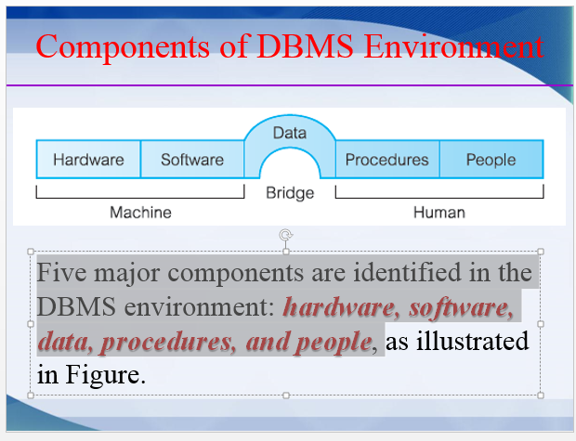

* **Hardware**
  + Can range from a single personal computer, to a single **mainframe** (computers used primarily by large organizations for handling large amount of bulk data processing, such as census and banks), to a network of computers.
* **Software**
  + DBMS, operating system, network software (if necessary) and also the application programs.
* **Data**
  + Used by the organization and a description of this data called the ***schema***.
  + The structure of the database is called the ***schema***.
  + The ***schema*** consists of four tables, namely: **PropertyForRent, PrivateOwner, Client, and Lease**.
* **Procedures**
  + **Instructions and rules that should be applied to the design and use of the database and DBMS. For example, the following procedure needs to follow by the staff**
  + **log on to the DBMS**
  + **use a particular DBMS facility or application program**
  + **start and stop the DBMS**
  + **make backup copies of the database**
  + **handle hardware or software failures**
  + **change the structure of a table, reorganize the database across multiple disks**
* **People**
  + **The final component is the people involved with the system**

1. Discuss the roles of the following personnel in the database environment:
   1. Data administrator

**responsible for the management of the data resource including database planning, development and maintenance of standards, policies and procedures, and conceptual/ logical database design.**

* 1. Database administrator

**responsible for the physical realization of the database, including physical database design and implementation, security and integrity control, maintenance of the operational system, and ensuring satisfactory performance of the applications for users.**

* 1. Logical database designer

**concerned with identifying the data (the entities and attributes), the relationships between the data, and the constraints (business rules) on the data that is to be stored in the database. For example, a member of staff cannot manage more than 100 properties for rent or sale at the same time;**

* 1. Physical database designer

**responsible for the real implementation of the database.**

**mapping the logical database design into a set of tables and integrity constraints**

**selecting specific storage structures and access methods for the data to achieve good performance**

**designing any security measures required on the data**

* 1. Application developer

**responsible to provide the required functionality to the end-users.**

**Application Developers work on a specification document produced by systems analysts.**

**This activity includes retrieving data, inserting, updating, and deleting data.**

* 1. End-users

**The end-users are the ‘clients’ for the database, which has been designed and implemented, and is being maintained to serve their information needs.**

1. Discuss the advantages and disadvantages of DBMSs.

Advantgages

1. **Control of Data Redundancy**

* **Database approach attempts to eliminate the redundancy by integrating the files so that multiple copies of the same data are not stored.**

1. **Data Consistency**

* **If a data item is stored only once in the database, any update to its value has to be performed only once and the new value is available immediately to all users.**

1. **More information from the same amount of data**

* **With the integration of the operational data, it may be possible for the organization to derive additional information from the same data.**

1. **Sharing of Data**

* **Database belongs to the entire organization and can be shared by all authorized users.**
* **New applications can build on the existing data in the database.**

1. **Improved Data Integrity**

* **Database integrity refers to the validity and consistency of stored data.**
* **Integrity is expressed in terms of constraints, which are consistency rules that the database is not permitted to violate. For example, proper format of date (xx/xx/xxxx)**

1. **Improved Security**

* **Database security is the protection of the database from the unauthorized users.**
* **Without suitable security measures, integration makes the data more vulnerable than file-based systems.**

1. **Enforcement of Standards**

* **These may include departmental, organizational, national, or international standards for such things as data formats to facilitate exchange of data between systems, naming conventions, documentation standards, update procedures, and access rules.**

1. **Economy of Scale**

* **Combining all the organization’s operational data into one database, and creating a set of applications that the work on this one source of data, can result in cost savings.**

1. **Balance conflicting requirements**

* **DBA can make decisions about the design and operational use of the database that provide the best use of resources for the organization as a whole.**

1. **Improved data accessibility and responsiveness**

* **As a result of integration, data that crosses departmental boundaries is directly accessible to the end-users.**
* **Many DBMSs provide query languages or report writers for various new demands**

1. **Increased productivity**

* **DBMS provides many of the standard functions that the programmer would normally have to write in a file-based application.**

1. **Improved maintenance through data independence**

* **DBMS separates the data descriptions from the applications, thereby making applications immune to changes in the data descriptions.**

1. **Increased concurrency**

* **In some file-based systems, if two or more users are allowed to access the same file simultaneously, it is possible that the accesses will interfere with each other, resulting in loss of information or even loss of integrity.**

1. **Improved backup and recovery services**

* **In the event of a failure, the backup is restored and there are no long delays in the normal working.**

Disadvantages

1. **Complexity**

* **Database designers and developers, the data and database administrators, and end-users must understand this functionality to take full advantage of it.**
* **Failure to understand the system can have serious consequences for an organization.**

1. **Size**

* **The complexity and breadth of functionality makes the DBMS an extremely large piece of software, occupying many *mega/giga bytes of disk space* and requiring substantial amounts of memory to run efficiently.**

1. **Cost of DBMSs**

* **The cost of DBMSs varies significantly, depending on the environment and functionality provided. For example, a single-user DBMS for a personal computer may only cost US$100.**
* **Large mainframe multi-user DBMS servicing hundreds of users can be extremely expensive, perhaps US$100,000 or even US$1,000,000.**

1. **Additional hardware costs**

* **The disk storage requirements for the DBMS and the database may necessitate the purchase of additional storage space.**

1. **Cost of conversion**

* **In some situations, the cost of converting existing applications to run on the new DBMS and hardware is significantly high.**
* **This cost also includes the cost of training staff to use these new systems, and possibly the employment of specialist staff to help with the conversion and running of the system.**
* **This cost is one of the main reasons why some organizations feel tied to their current systems and cannot switch to more modern database technology.**

1. **Performance**

* **A file-based system is written for a specific application, such as invoicing, thus the performance is generally very good.**
* **However, the DBMS is written to be more general.**
* **As a result, the effect is that some applications may not run as fast as they used to.**

1. **Higher impact of a failure**

* **The centralization of resources increases the vulnerability of the system.**
* **Since all users and applications rely on the availability of the DBMS, the failure of certain components can bring operations to a halt.**